Gamma Distribution:

pdf: 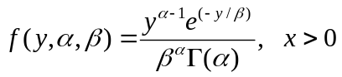

cdf: No simple explicit expression.

Mean = 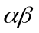
Variance =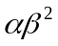

likelihood = 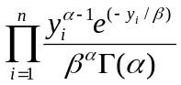

loglikelihood = 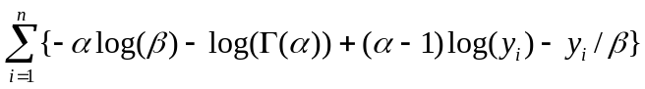

Special cases include:

(i) Exponential distribution (= 1).
(ii) Chi-squared distribution with k degrees of freedom (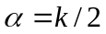and 

